**Lab 3**

**Group:** [**2021S2_REG_WE_37**](https://docs.google.com/presentation/d/1rWUfeWEuTJpX_bc_7fO1j5rDpW3un5gL6jfevgR5S8A/edit#slide=id.ge4e4ca7308_0_136)

| No | Members | Function |
| --- | --- | --- |
| 1. | M.M.A.N.N.Sandeepa IT19245584 | 1.Common Medicines  2.Login, register, reset password  3.Admin |
| 2. | Praveena.T IT19243672 | 1.Pharmacist, profile  2.Prescribed medicines  3.Ongoing orders - order status, add an order, order history  4.Add Address(GPS mapp) |
| 3. | J.A.D.S.Crishani IT19387536 | 1.Delivery boy with the vehicle, profile  2.Payment, delivery  3.Add new Family Members |
| 4. | Abarna.U IT19116952 | 1.User, order, cart, profile  2.Online complain page/ enquiry (feedback)- Home |

1.Personas

1. Admin

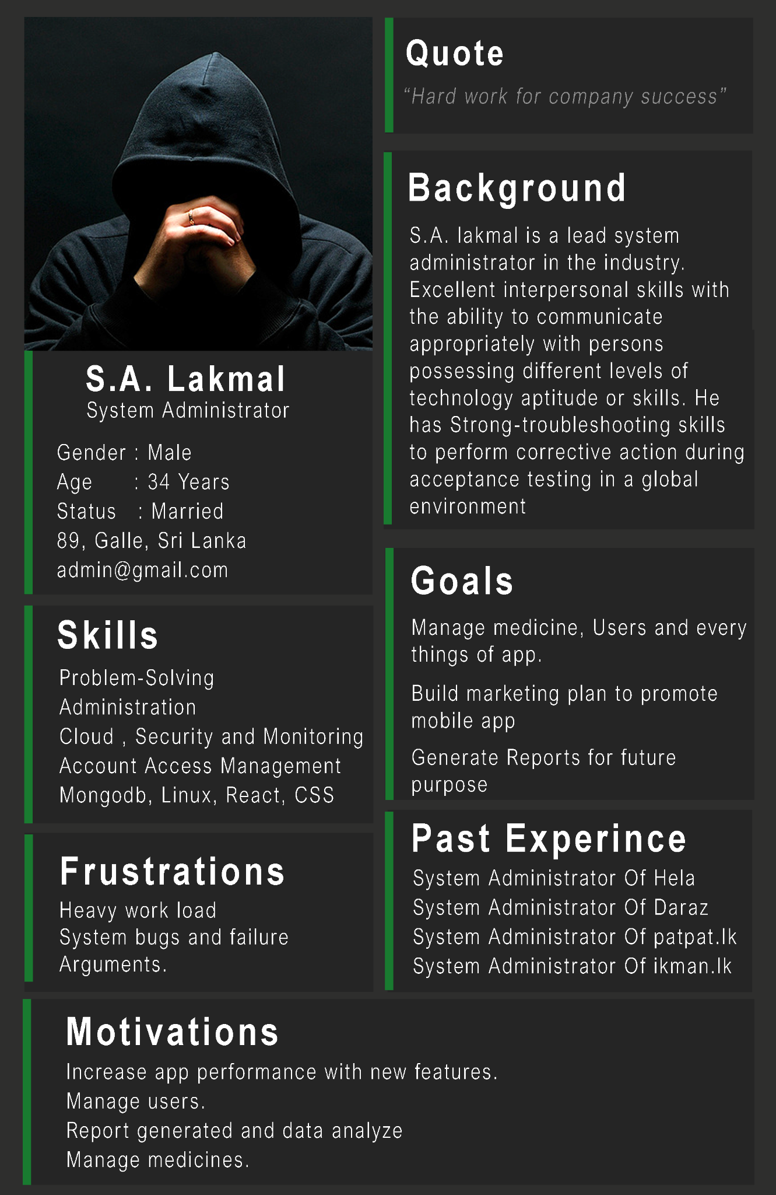

1. Pharmacist

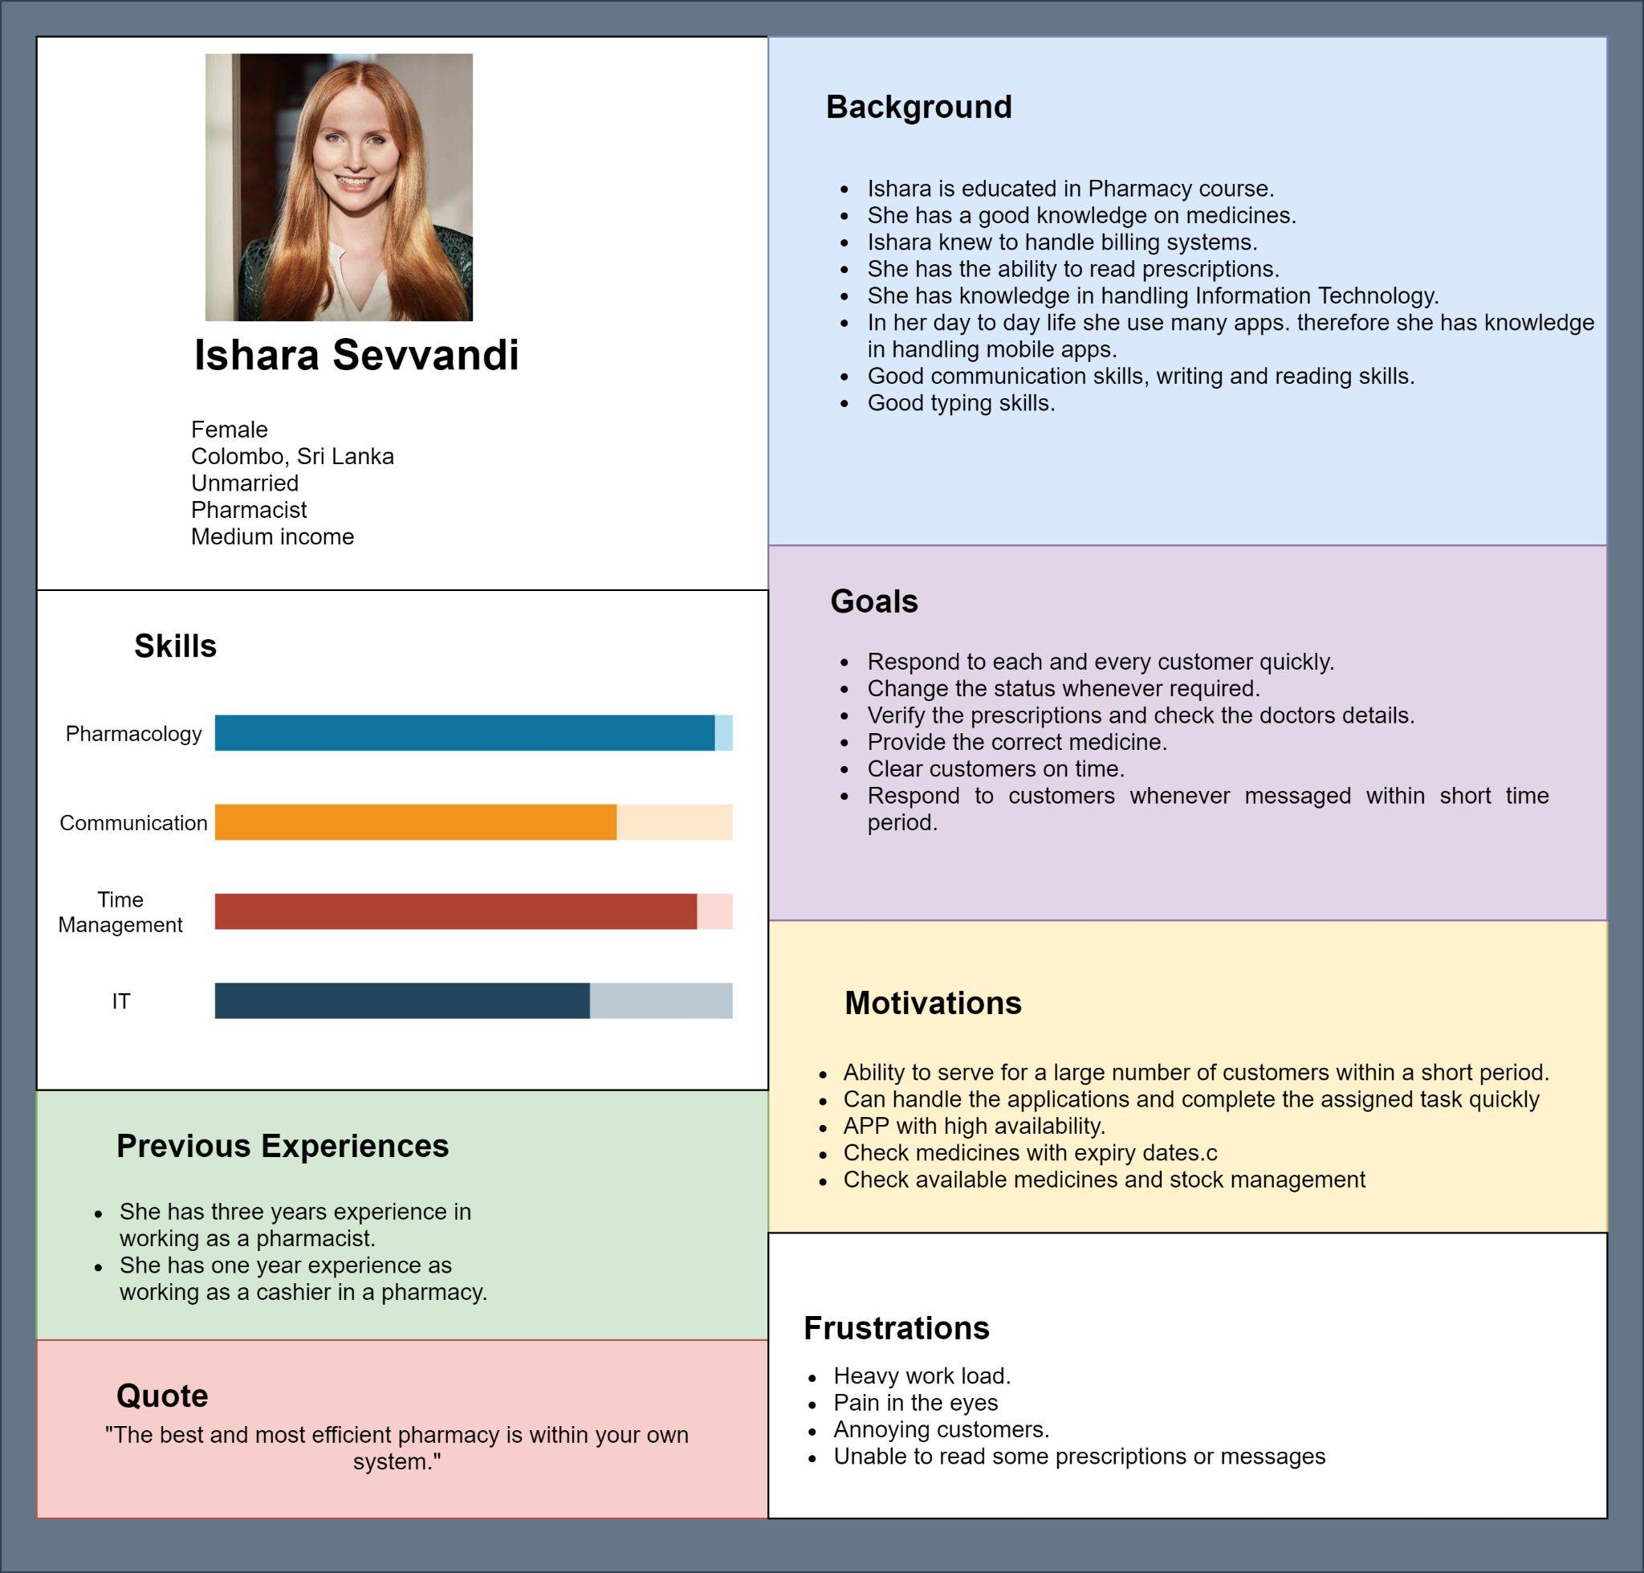

1. Normal user (Patient)
2. Delivery person

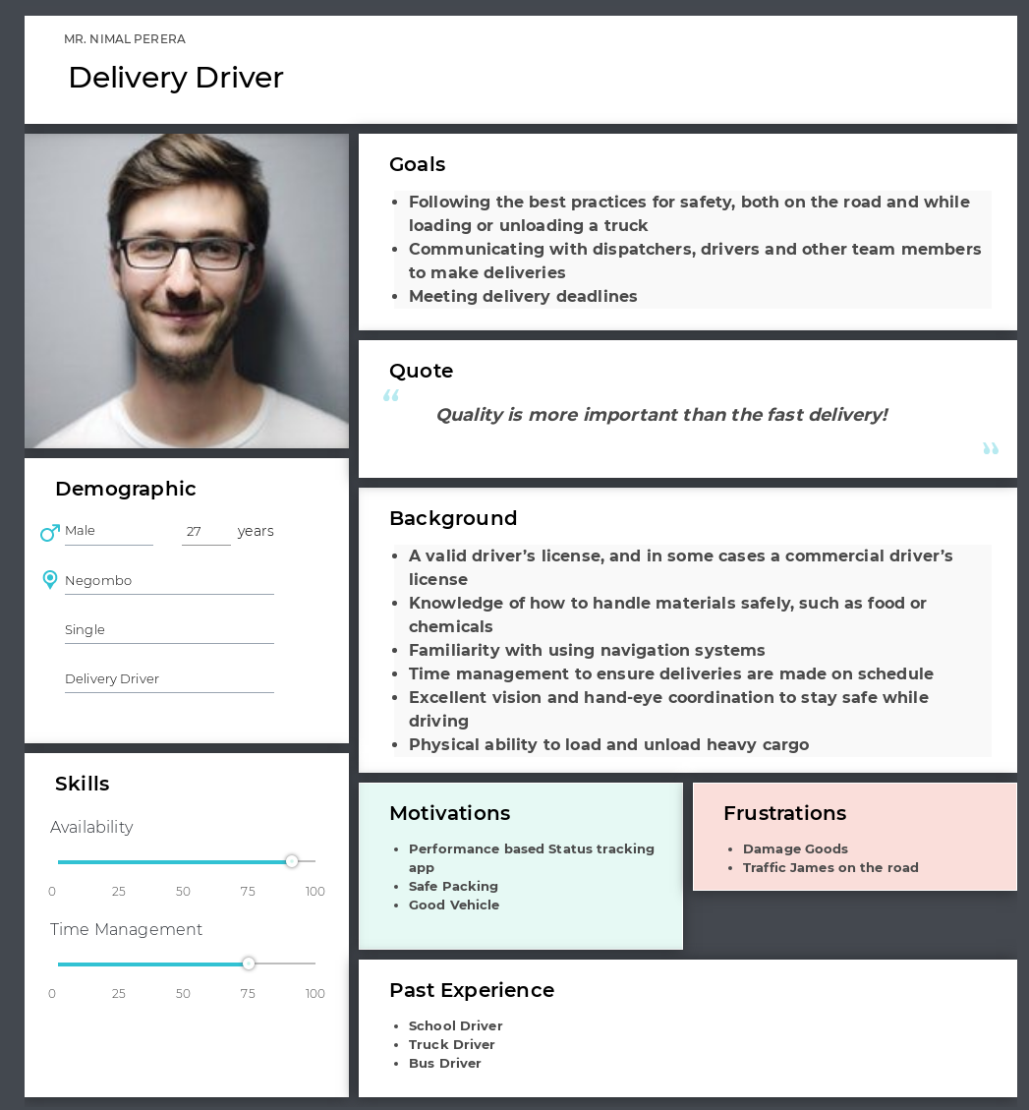

**2.Empathy map**

**User**

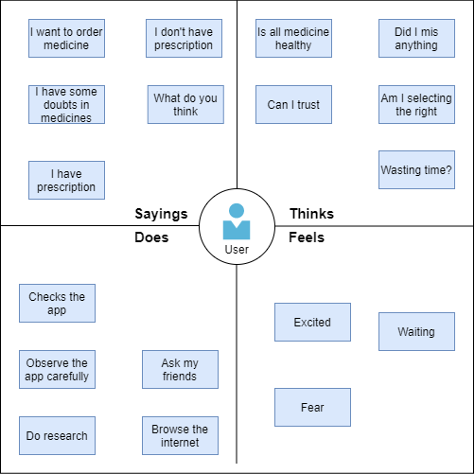

**Registered User for buy common medicine**

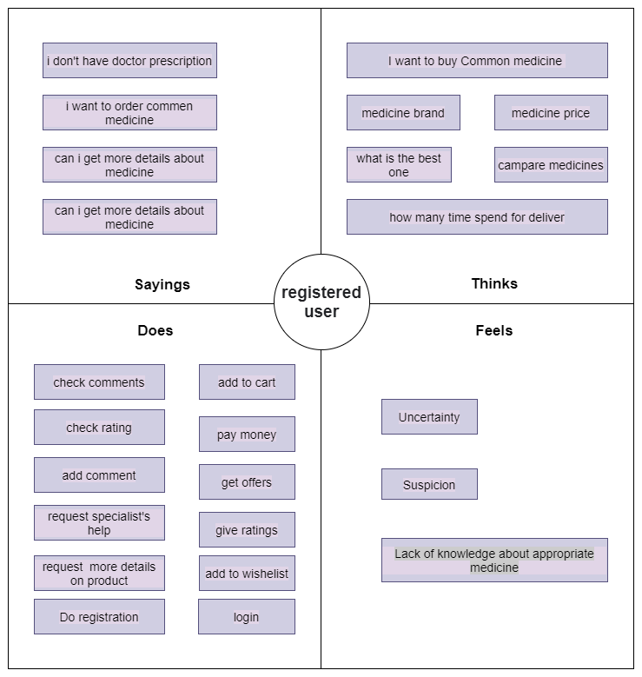

**Delivery**

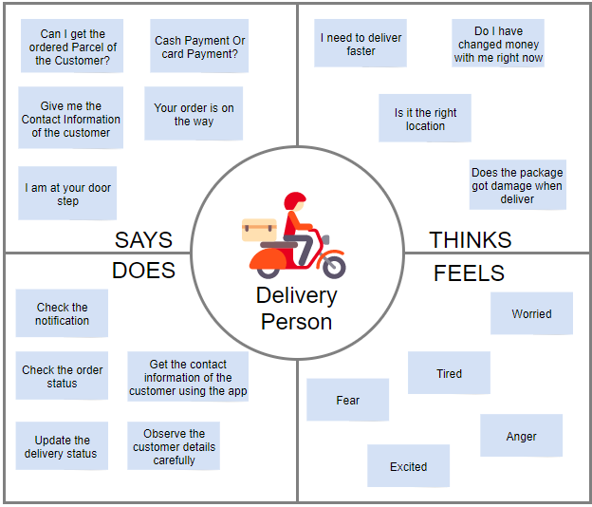

**Pharmacist**

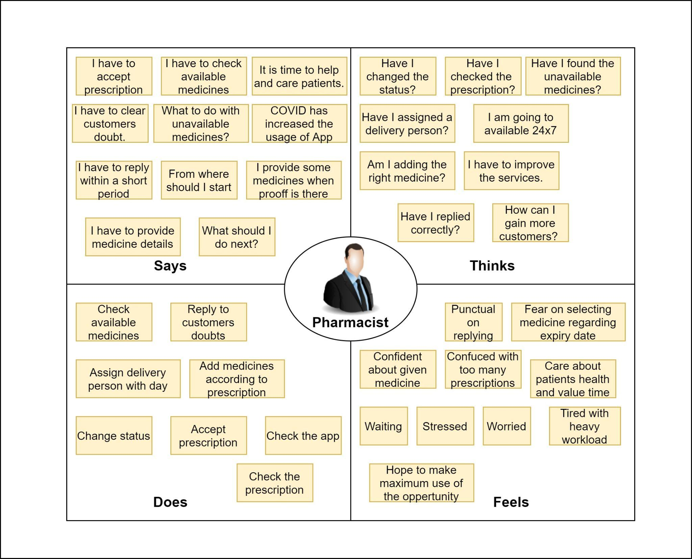

**Admin**

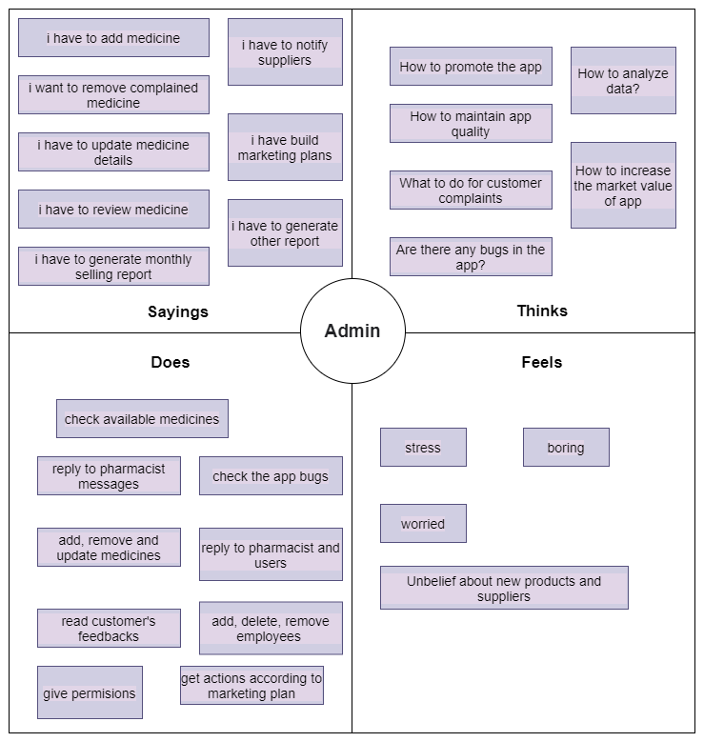

**3.User Stories**

**User**

As a user I want to upload the prescription so that I can order medicine.

As a user I want to view common medicine so that i can buy and order common medicine.

**Delivery**

As a Delivery Manager I need to deliver the ordered medicine to the right customer So that i can update the status of the order as complete.

**Pharmacist**

As a pharmacist I have to check and accept the prescription provided by the customer so that I can provide the required medicine on time.

**Admin**

As an admin I want to view data in the app so that I can manage and analyze the data.

**4.User Flow**

**User**

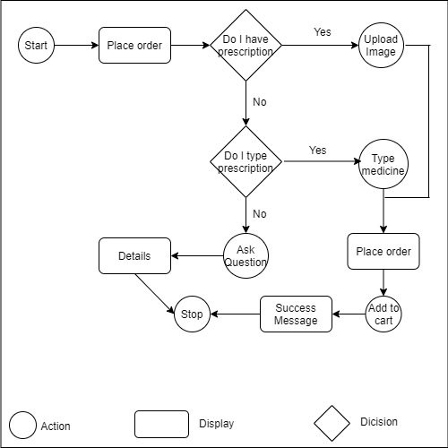

**User(Buy Common Medicines)**

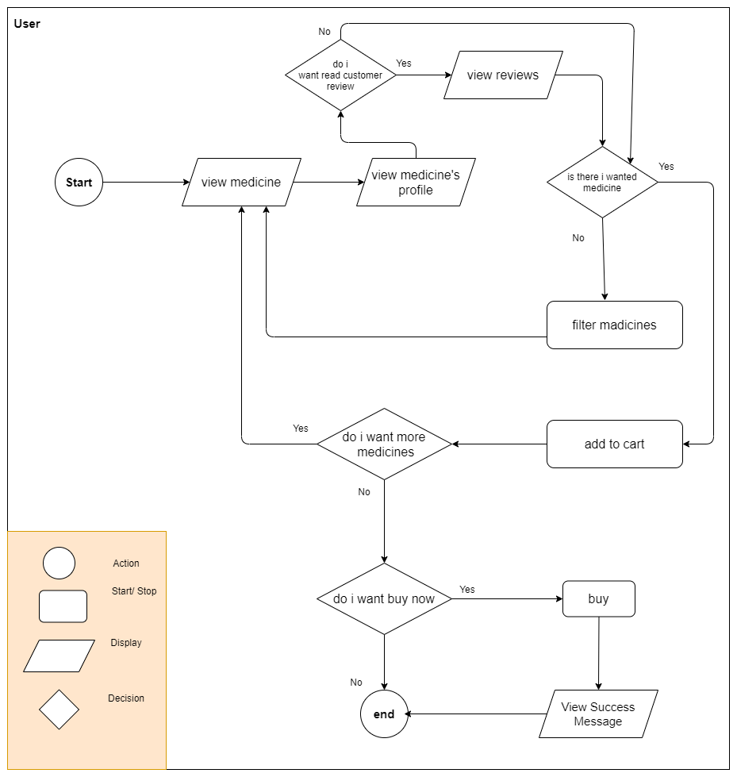

**Delivery**

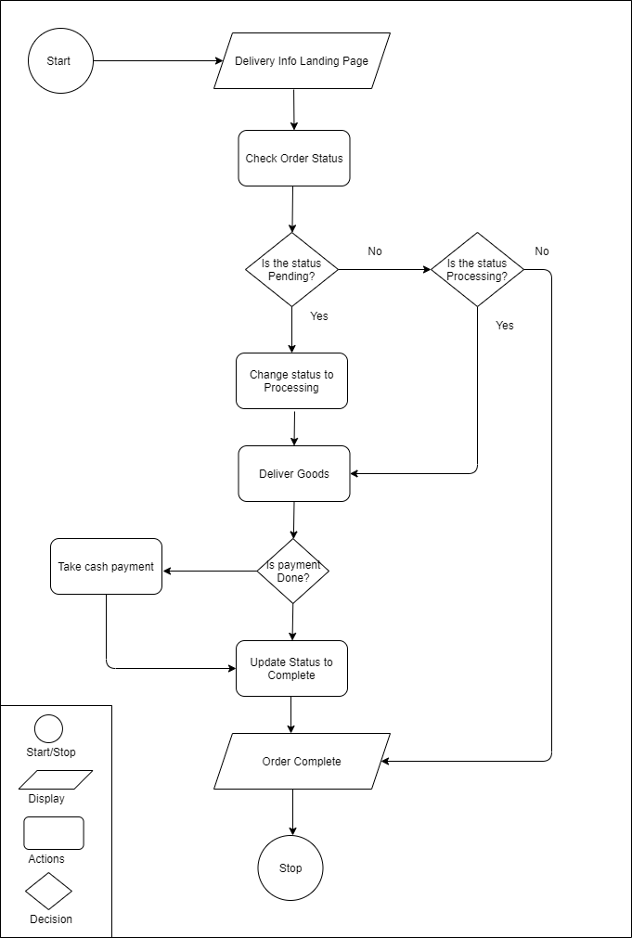

**Pharmacist**

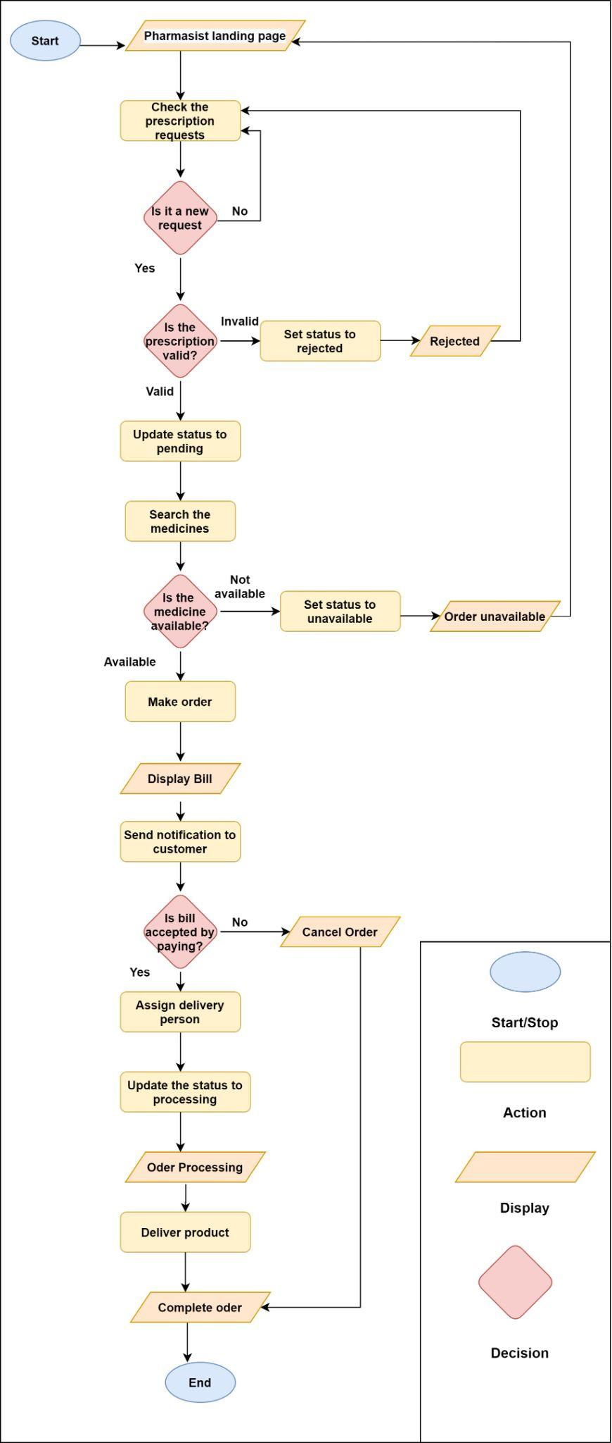

**5.Service Blueprint**

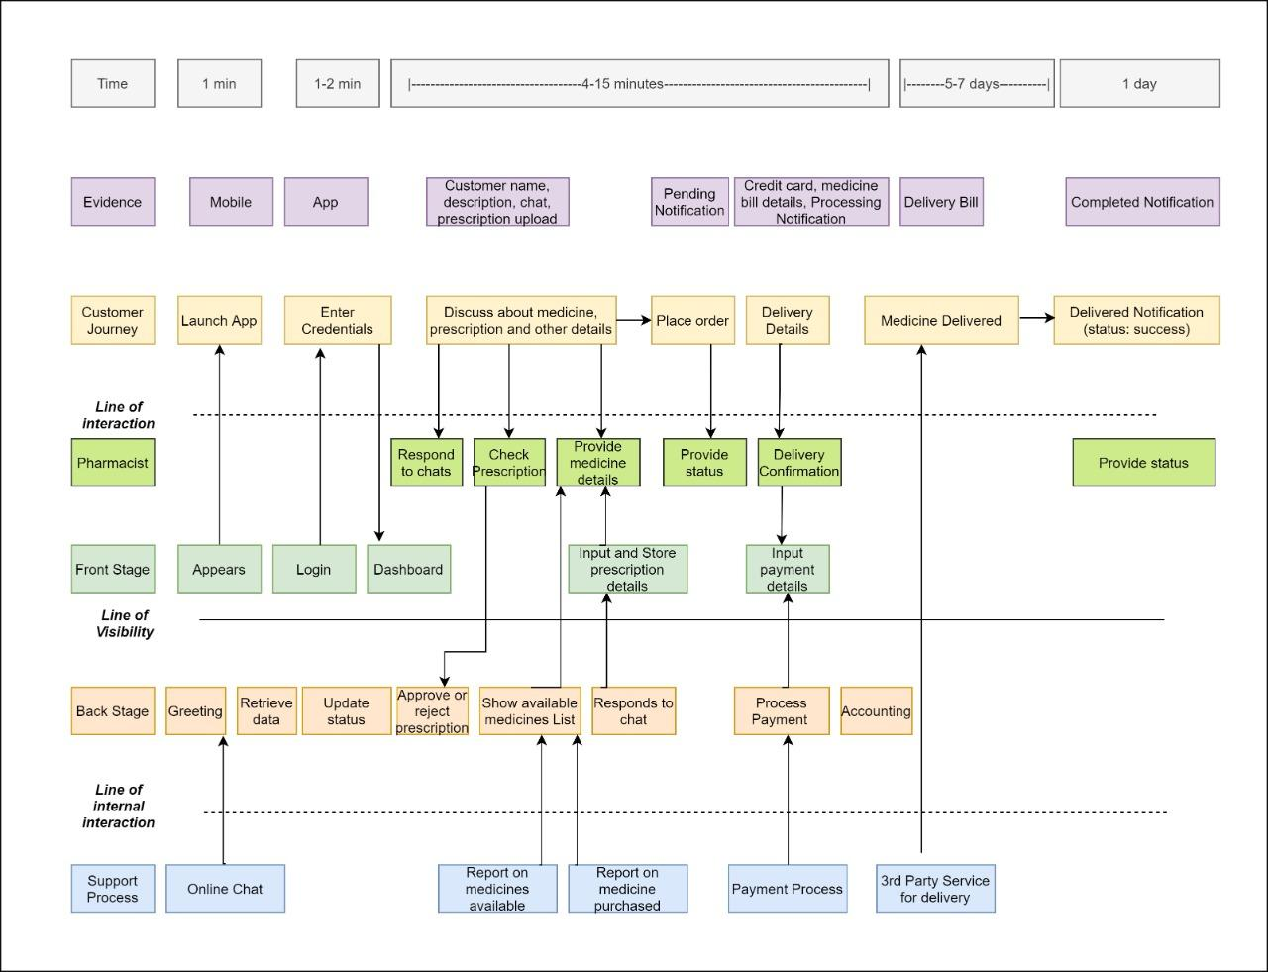

Contributions

| No | Members | Contributions |
| --- | --- | --- |
| 1. | M.M.A.N.N.Sandeepa IT19245584 | 1.Admin  2.Personas- Admin, registered User  3.Service Blueprint |
| 2. | Praveena.T IT19243672 | 1.Pharmacist  2.Personas - Pharmacist  3.Service Blueprint |
| 3. | J.A.D.S.Crishani IT19387536 | 1.Delivery boy  2.Personas - Delivery  3.Service Blueprint |
| 4. | Abarna.U IT19116952 | 1.User  2.Personas -User  3.Service Blueprint |